# Cal-IBIS Polygons

## Polygon goal

* We desired a consistent polygon with which to search databases for the snapshot that is uploaded to Cal-IBIS.
* These polygons needed to be a biologically adequate size to capture species of interest, while not collecting data for a large proportion of the Pacific that is not of interest to island researchers.
* We settled on a 10 km buffer around each of the islands. When an island’s buffer intersected the mainland, we buffered the mainland by 1 km and removed this area from the island buffer.

## How the Polygons were made

* Rocky supplied base polygons for each island:
  + “[Rocky] used the 8 california islands CUSP [https://shoreline.noaa.gov/data/datasheets/cusp.html], excluding islets. Buffered 10km. Federico Mendez of GECI provided MX files. I reprojected the MX data to NAD83 Zone 11 and merged them, buffered 10km, then combined all of them into one file.”
* Josie removed mainland from buffers
  + Mainland Mexico borders extracted here: <https://data.humdata.org/dataset/mexican-administrative-level-0-country-1-estado-and-2-municipio-boundary-polygons>
  + Reprojected to NAD83
  + Buffered mainland by 1 km
  + Removed buffered mainland areas from island polygons
* Simplified shapes to have fewer points to draw them (“simplify” tool with tolerance at 1km).

## Folders/Files:

* The “For backup” folder includes WKT files that may be incorrect, broken, or need minor fixes, but Josie wasn’t comfortable deleting.
* “Island_WKTs.csv” is a file with the WKT for each island in a csv form
* “Master_CalIBIS_Polygons.kmz” is the master file for all of the polygons

## Images of each island’s polygon (images not all at the same scale)

California Islands

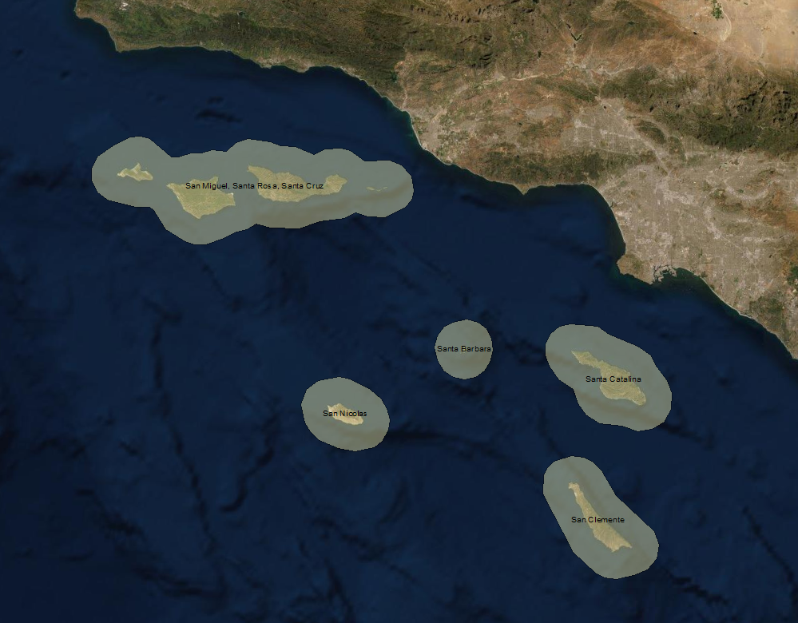

Coronados and Todos Santos

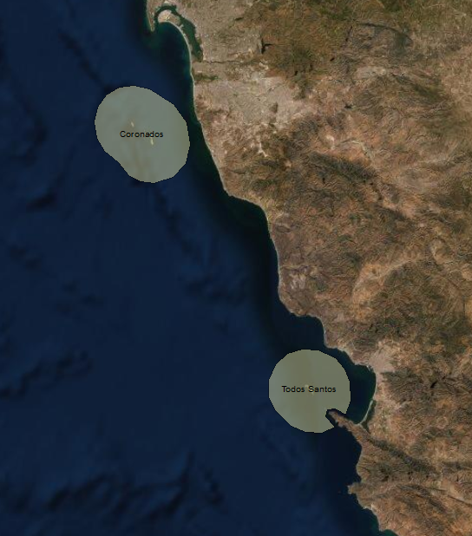

San Martin and Geronimo

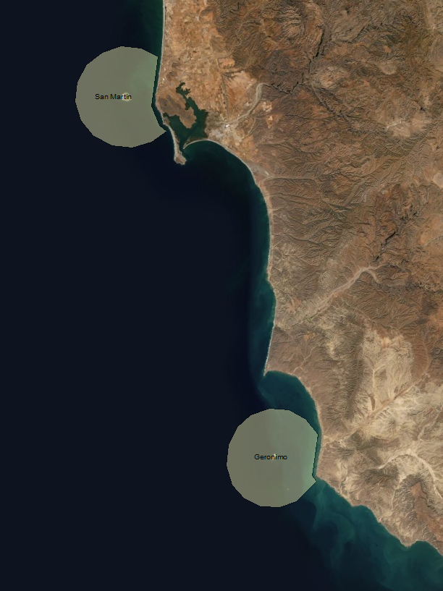

San Benito, Cedros, Natividad

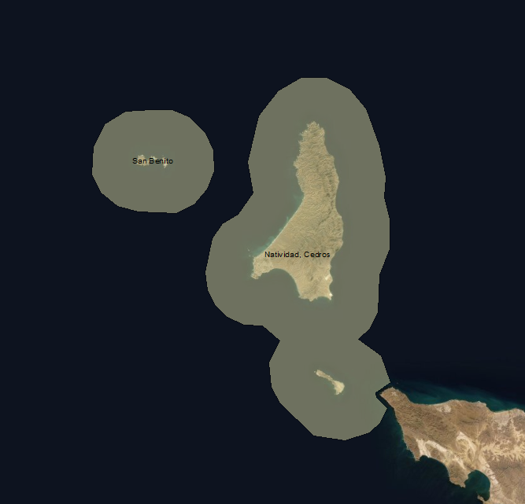

Guadalupe

